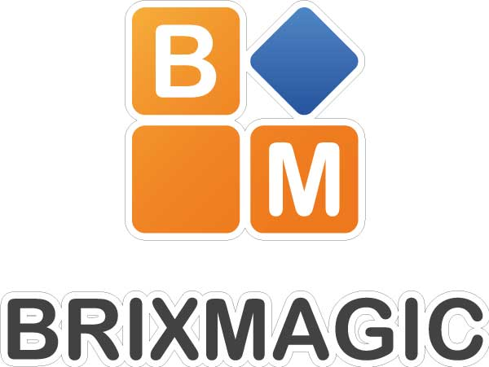

**Garden Creek School**

**(Grade 1-2)**

Date: Monday, Feb 2nd – April 27th

No class on: Feb 17th, Mar 2nd, Apr 13th

Time: 2:05-3:05

Registration deadline: January 31st

**Contact Us**

E-mail: tommy_meng@hotmail.com

Phone: (506)259-8833

Please send this registration form with payment to school

**Personal Information:**

Parent’s Name: __________________ Phone: ____________ Email: ____________________________

Child’s Name: __________________ DOB: ____________ Grade: __ Home Teacher: ______________

Home Address: _______________________ City: _____________ Postal Code: _______

**Please indicate who will pick-up your child:**

Walk home: __ Daycare: ______________ Guardian1: _______________ Guardian2: _______________

**Special Instructions/Medical Awareness:** _________________________________________________

**Payment:**

Please attach payment of $ 125 , cash or cheque made to (Yi Yuan) . An NSF fee of $10 will be charged on returned cheques.

We also accept e-transfer to [joy365chris@gmail.com](mailto:joy365chris@gmail.com) , please set password as ‘Ledo’.

I understand and know the program my child participates may involve risk of accidental injury and I want my child to participate in this program. I (on behalf of my child) waive, release and discharge Ledo Education including its officers, employees, instructors and assistants, and all officers and employees of the school or community center sites where said the program will take place, for any and all claims for damages for personal injuries, or claims for damages to property, which my child or my child’s heirs, assigns, executors or administrators may have or which may accrue to my child’s participation in this program. I have read the above and understand important legal rights are being waived.

Parent’s Signature: _____________________ Date: ____________

**Theme: Jurassic World**

Are you ready to play in BrixMagic’s Jurassic World Serie? This time you will build motorized dinosaur models that you have seen in a dinosaur world, you will learn how to make the models spin, roll, turn and rock, the models can move as you can see in the Jurassic parks! You will build a different model each week. Come and join us!

BrixMagic After-School Classes use LEGO® blocks to deliver high quality building with fun, kids build a new model every week using classic and technical LEGO® blocks loved by generations of children, it is a great experience to kids.

After School Classes

Registration Form (1-2)